How to Modify SSID and Password of W312A
Step 1: Power on the AP, and connect your PC to one of the LAN ports by a cable, as the following illustration;
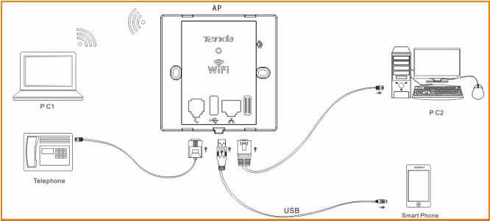

Step 2: Set a static IP for local area connection within the following range: 192.168.0.X (2-254), and with the subnet mask: 255.255.255.0;
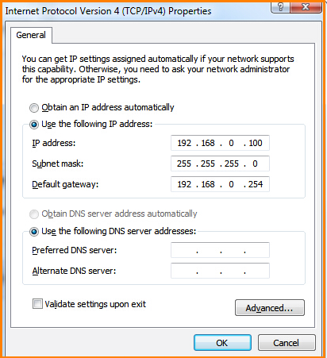

Step 3: Launch a web browser to login AP’s web page;
- Launch IE browser, input 192.168.0.254 in the address bar and press Enter;
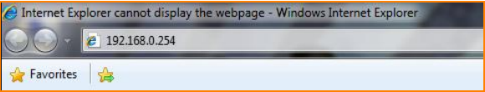
- Type in the default username and password (admin for both) and click Login;
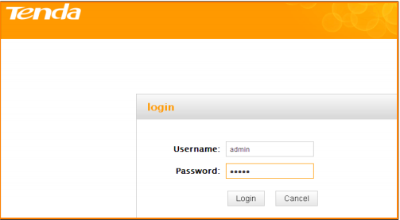
- Then enter this device’s web page;
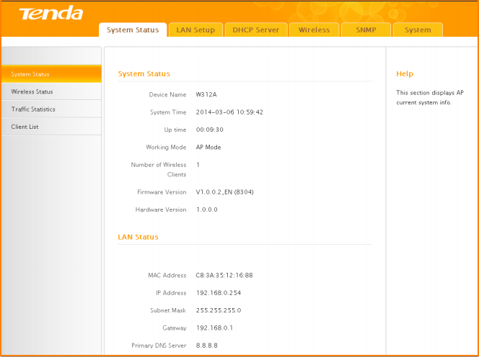

Step 4: Modify wireless SSID and wireless password of AP.
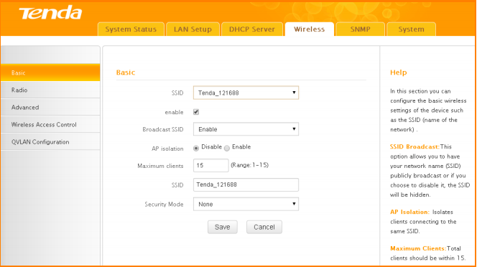
Note:
1. Change SSID for better suggestion when modifying wireless password.
2. Wireless will disconnect after modifying SSID and password, so it should be connected by scanning again.

